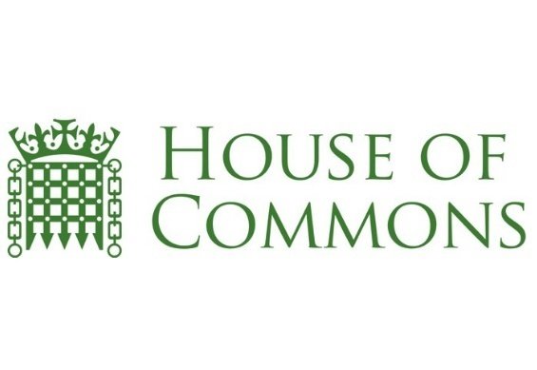
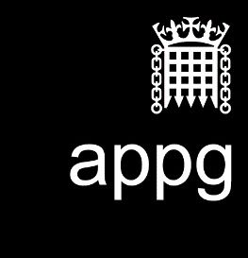

The All Party Parliamentary Group on Bereavement Support
Minutes
Date: 14 November 2018

Location: Portcullis House

Present: Linda Magistris (LM) Philip Satherley (PS)
Carolyn Harris MP (CH) (Part) Alice Davies (AD)
Jan Soulsby (JS) Helen Charalambous (HC)
Professor Jennifer Leeming (JL) Natasha Bradshaw (NB)
Mohamed Omer (MO) Emma Radley (ER)
Rabbi Daniel Epstein (DE) Andy Langford (AL)
Sarah Morgan-Davies (SMD) Carolyn Brice (CB)
Sammy Ashby (SM) Ann Chalmers (AC)
Dr Julie Alexander Cooper (JAD) Alison Penny (AP)
Denise Parkinson (DP) Poppy Mardell (PM)
Helen Churchill (HC)
Eve Henderson (EH)

Apologies: Fiona Murphy Steve Marshall
Rhian Mannings Ruth Sheridan
Kim Bird Paula Abramson
Erin Thompson Jenny Ward
Jen Coates Liz Pryor
Paul Parsons Julie Love
Iain Lowrie

All members introduced themselves.
LM ran through APPG Our Year 2017-2018 (attached) which details the progress that has been made on the issues discussed over the year. Alice Davies mentioned that Family Liaison Officers (FLO) are being trained with bereavement nurses which is helping to raise awareness of the Swan initiative with different police forces. Most families take up the offer of the bereavement nurse particularly those going through an inquest – this also helps the coroners. Professor Leeming proposes to meet shortly with the Chief Coroner to address bereavement issues, particularly the second post mortem which is permissible when there has been an unlawful death. This is a very important issue in the Muslim and Jewish communities. MO and DE expressed interest at joining this meeting.
LM raised the subject of launching a National Grief Awareness Week (NGAW) in 2019. This suggestion has been made before and AC commented that perhaps we may not want to risk diluting Dying Matters week. AD commented that her experience in Manchester of Dying Matters Week is that they primarily focus on pre-bereavement. A Grief Awareness Week would focus totally on bereavement – all APPG participants and bereavement services across the country could help dispel myths, create compassionate societies and work towards normalising grief.
JL explained that she did not see NGAW as diluting or excluding – every charity has a package of care to offer which can assist in the lack of grief awareness.
CB very much supported the idea of NGAW and pointed out that it should encompass the disenfranchised for instance those affected by suicide or drug and alcohol related deaths.
DE supported the suggestion of a NGAW to raise awareness of all issues around grief and loss and a new campaign would be an opportunity to highlight the tradition and culture of bereavement support offered to those experiencing a death in the Jewish community.
LM stated that we should not be in competition, that all charities and UK bereavement services could benefit from this national campaign, to share our strengths and expertise, working in collaboration for the good of the next person who loses someone they love. She explained that the vision is for communities to come together to help each other and find their local support. The aim is also for smaller bereavement support groups to have a national platform to highlight their own services to a wider audience and reach those needing their help. The aim is to open conversation on a national level around the topic of grief and loss, raise funds and awareness for all UK support services and generally is designed to help us as a nation become more aware of the needs of those impacted by grief and to ensure that the bereaved have access to a choice of support they need at the time they need it most, wherever they live in the UK.
LM envisaged selling umbrella pin badges during the NGAW as a new collaborative symbol of help and hope for the bereaved. It was suggested that an action group be formed to coordinate the set up for Awareness Week - JAC would draw up a job specification for a project coordinator. We could also speak to Dying Matters to find out how their week evolved.
It was noted that not all deaths occur through a hospice or hospital so a Grief Awareness Week would offer support to families affected by unexpected deaths. It could also help focus on our multi-cultural society – we could learn from different communities/faiths’ systems of coping with grief and bereavement. It would also give a platform for extending the newly passed Parental Leave Bill so that all parents who lose a child, regardless of their age, receive the two week leave period.
Sammy Morgan-Davies from SUDEP then gave a brief outline of the work they carry out supporting families who have lost a loved one to epilepsy – 50% of the board have personal experience of epilepsy death. There are approximately 600,000 epilepsy sufferers in the UK and they are 24 times more likely to die prematurely than non-sufferers. In 2002, 42% of epilepsy deaths were avoidable. Sudden deaths peak at the ages of 20 – 40 but not limited to this age range and those suffering strokes is the only higher cause of death. As deaths often occur away from hospital, in the open or in the home, the police are often involved which causes more distress for families. SUDEP has a specialist team that runs a helpline and counselling service.
JL was immediately concerned about the number of deaths that were avoidable; coroners have to report where deaths can be prevented and she could work with JL to arrange for a check list to be added to the coroner’s website to ensure this is captured in future.
LM read out a letter that the Good Grief Trust had received from Brenda Lawson, Brenda’s daughter had died in 2015 on a school trip to France. The inquest has still not taken place and she and her family have received no help from the foreign office and they were not entitled to a family liaison officer due to the death taking place abroad. Brenda outlined the lack of choice of bereavement support offered to her and called for a more collaborative approach to signposting to help families after such a traumatic experience.
CB then read out a letter from a family complaining about the level of service received from their coroner’s office. JL advised that the only recourse is to complain to the Chief Coroner. It was pointed out that families put up with bad practice because they do not know it is bad as they may not have encountered coroners before. We should strive for an even, caring, compassionate service across the UK coroner’s offices.
JL pointed out that the Chief Coroner has no powers, they can only set guidelines. Her belief is that there should be an inspection service, in this way the local authorities would have to fund it properly as they would receive fines for poor inspections and we could start to standardise best practice.
JL is currently attempting to set up a meeting with the Chief Coroner and will raise the relevant points discussed in this meeting at that time. Any members interested in joining this meeting, to contact JL.
Date of the next meeting to be confirmed

