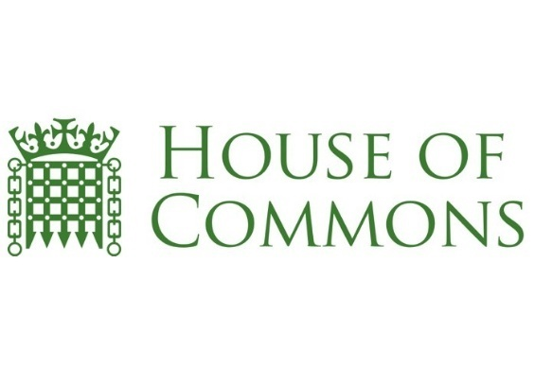


The All Party Parliamentary Group on Bereavement Support
Minutes
Date: 12 December 2017

Location: Palace of Westminster

Present: Linda Magistris (LM)
Carolyn Harris MP (CH)
Debbie Kerslake (DK)
Fiona Murphy (FM)
Alison Penney (AP)
Jan Soulsby (JS)
Lee Pycroft
Helen Byrne
Finella Craig
Paul Parsons

Apologies: Camilla Gooden Ruth Sheridan
Jane Harris Shirlie Kemp
Ann Chalmers Steve Marshall
Liz Dempsey Tracey Bleakley
Ruth Sheridan

DK wanted to confirm that Dying Matters week is going to have more of a focus on bereavement than was reported in the last minutes. The representatives from GGT confirmed that they would have another meeting with the Dying Matters teams to assist them in offering more bereavement support in 2018. We can see how we can work together and help communities be inclusive in a new way using Dying Matters’ expertise. It was pointed out that there is a huge overlap between Dying Matters and Grief Matters but they are two different focuses. We need to cater to both sectors, those dying and those left behind.
LM then gave an update on the GGT card. The Royal Marsden has agreed to use it along with the hospitals that Fiona Murphy looks after in Greater Manchester. Rita Wilkinson, Senior Police Coroner’s Officer in the South Manchester area has also agreed to distribute the cards through all 5 coroner’s offices. Each of these entities will also be funding the cost of the cards. It was suggested they should be offered to all hospices and GGT should put together costing for funding. CH suggested that Co-op and Dignity undertakers should be approached for funding.
LM then introduced Helen Byrne who is a mental health nurse who told of her experience of bereavement support within the health profession. Helen’s husband, Ed, contracted a rare asbestos related cancer and was unwell for 3 years before his death. Helen was given a lot of support during this time, she was able to be work flexibly and was given time off but all support fell away after Ed’s death. Helen had moved teams at this time but it was still within the same environment and she still knew everyone within her team. After 4 months, Helen received a letter asking her to attend a meeting, indicating the possibility of dismissal. Helen agreed at the meeting to medically retire. There were a catalogue of administrative errors which included Helen’s health reports being sent to a different staff member and receiving a standard letter that instead of stating Helen’s name, the words “Insert Name Here” were left in place.
Upon enquiry, Helen’s workplace has no bereavement policy in place either for dealing with bereaved patients or bereaved staff. Helen then contacted her chief executive and talked through her treatment and they are now creating a standardised template as a start that will acknowledge a member of staff’s loss. Helen also spoke with Wiltshire Council who also have no bereavement policy but are also taking on board the standard template. JS queried whether councils speak to each other and CH confirmed there is a Local Government Association who can introduce policies that will filter down through all councils.
CH also confirmed that she is currently working on a bill going through Parliament to ensure that parents who lose children are entitled to compassionate leave. DK confirmed she would speak to CH regarding legislating for bereavement policies as part of the taskforce. CH is to attend a committee meeting shortly and will know more then what help or advice that the APPG can offer.
AP stated that we should lobby MPs to raise awareness and she would send through her ideas.
Then Paul Parsons quoted Curtis & Burns research that 1 in 10 people in the work force are bereaved and that bereaved people are twice as likely to visit their GP than non-bereaved people. FM stated that she is currently following up with 14 GPs so expects to have some valid data after 18 months.
It was discussed that doctors will sign off a bereaved person but on mental health grounds so there is no valid data on those who are signed off purely due to bereavement.
FM advised HB to return to the hospital where she worked to let them know all the progress she has made on improving bereavement support and to ask what they have done. She should also ask to speak at their End of Life Care Committee.
CH suggested that the next APPG in early February should focus on the Parental Leave Bill. DK/AP suggested that March’s APPG could focus on Kate Woodthorpe’s project on Death, Dying and Bereavement. CH suggested that June’s APPG could focus on the Child Death Review.
Date of the next meeting to be confirmed



